Servlet Container->

*It provides the runtime environment for JavaEE (j2ee) applications.

* The client/user can request only a static WebPages from the server. If the user wants to read the web pages as per input then the servlet container is used in java.

The servlet container is used in java for dynamically generate the web pages on the server side. Therefore the servlet container is the part of a web server that interacts with the servlet for handling the dynamic web pages from the client.

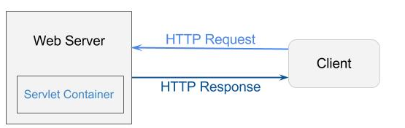

**Servlet Container States->**

The servlet container is the part of web server which can be run in a separate process. We can classify the servlet container states in three types: 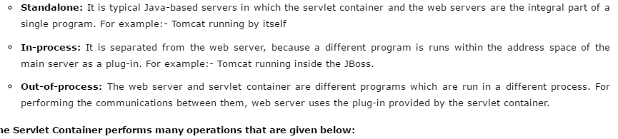

**The Servlet Container performs many operations that are given below:**

* Life Cycle Management
* Multithreaded support
* Object Pooling
* Security etc.

